Software Design Document

<Project Name>

Student Names

Table of Contents

1.0 System Vision 3

1.1 Problem Background 3

1.2 System Overview 3

1.3 Potential Benefits 3

2.0 Requirements 4

2.1 User Requirements 4

2.2 Software Requirements 4

2.3 Use Cases 4

3.0 System Components and Software Design 5

3.1 System Components 5

3.2 Software Design 5

4.0 User Interface Design 6

# System Vision

## Problem Background

With a significant number of road crashes happening between 2015 to 2020, it is hard to conduct quick research and find the nature, causes, fatality, impacts, etc. of all the accidents. A suitable data analysis tool is needed to categorize the accidents which can often overlap based on various factors. Similarly, raw data can be hard to understand and analyse for the users so an appropriate system for graphical representation of data is needed which can be different based on the user requirements.

## System Overview

Our software will be used to gather the raw data of all the accidents that happened in the State of Victoria from 2015 to 2020. The raw data will be organized based on the key words present in their reports and categorized accordingly. The keywords will be attributes through which one accident might be a part of one or many tables. The software will also facilitate the graphical representation of the crashes on said attributes and various numerical on charts thresholds as per the user requirements.

Similarly, the software will focus on the impacts of driving under the influence of drugs and alcohol and create a mapped diagram of the accident-prone areas in the state.

## Potential Benefits

1. An accurate graphical representation of the various causes of road crashes can help the concerned parties take necessary measures to mitigate such risks.
2. The refined statistics and information based on the keywords can be used to raise awareness among drivers on the leading causes of crashes.
3. A mapped presentation of accident-prone areas can help users ensure full attention at those areas and make government conduct investigations and make the changes necessary
4. Insurance companies can use the detailed information to set their policies accordingly.
5. Different industries like car manufacturing, road constructions, etc. can use the stats to make innovations and changes that are helpful in reducing crashes.

# Requirements

## User Requirements

Users of the Data Analysis and Visualisation Tool should be able to perform the following functions:

1. Perform general search of accident data.
2. Search accident data within selected date range.
3. Retrieve data for daily trends.
4. Output search results to chart(s)
5. Perform keyword search.
6. Retrieve search results where alcohol was a factor.
7. Retrieve search results where speed was a factor.
8. Search accident data within selected date range and apply one or more filters.

## Software Requirements

The Data Analysis and Visualisation Tool should be able to perform the following functions:

1. Crash Statistics Victoria.csv file must be within same path.
2. Take 30-60sec to load (max).
3. Allow users to define time period for date search by entering Initial and final (*to* and *from*) dates.
4. Filter the Victoria State Accident Dataset using the date search.
5. Filter the Victoria State Accident Dataset with user defined keywords.
6. Filter the Victoria State Accident Dataset to get the ratio of accidents happening during the day at different locations.
7. Filter the Victoria State Accident Dataset where alcohol was a factor.
8. Filter the Victoria State Accident Dataset where speed was a factor.
9. Sort search results in tabular format for better analysis and understanding.
10. Output search results in the form of charts and different infographics.
11. Generate graphs from selected dataset attributes.
12. Present selected dataset attributes information as 2D charts.

## Use Cases & Use Case Diagrams

## Use Cases

There are eight use cases identified. They are details in the table and use case diagrams below.

|  |  |  |
| --- | --- | --- |
| **Sr.#** | **Use Case** | **Description** |
| 01 | General Search of accident data | Filter-less search on accident data using the DAaV Tool returns unfiltered results. |
| 02 | Search accident data within selected date range (from *date1* to *date2*) | Will return results which occurred within selected date range. |
| 03 | Apply *Accident Daily Trends* filter | Will sort search results by time of day. |
| 04 | Visualize Output on Charts | Generate chart to show the number of accidents on average in each hour of the day within selected time period. |
| 05 | Perform *Keyword* search | Will return search results which contain the *Keyword(s)* |
| 06 | Apply *Alcohol* filter | Alcohol time filter will return results where alcohol was a factor |
| 07 | Apply *Speed Zone* filter | Will return results which occurred within specified *Speed Zone.* |
| 08 | Search accident data within selected date range and apply one or more filters | Will modify search results within selected date range based on *Keyword*, *Alcohol* and/or *Speed* *Zone* filters |

## Use Cases & Use Case Diagrams

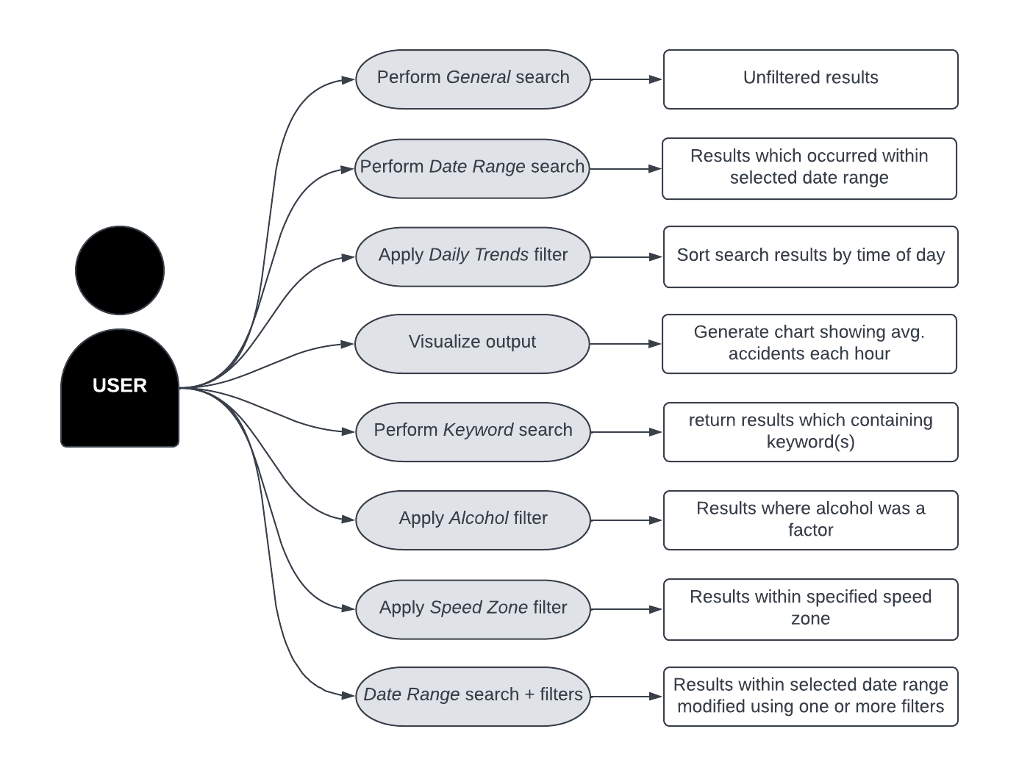

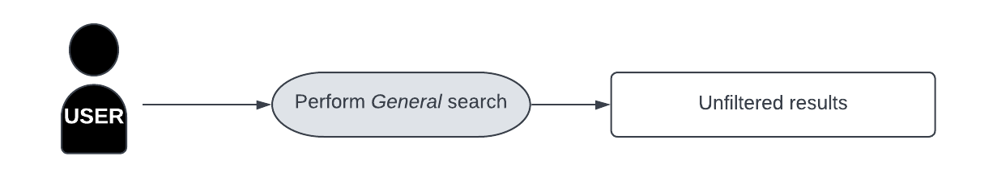

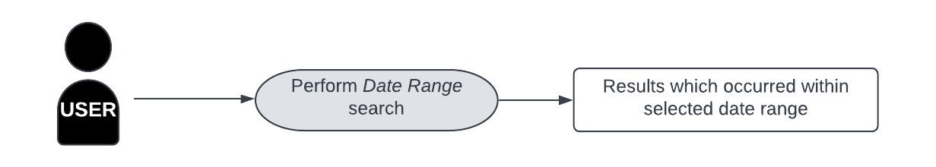

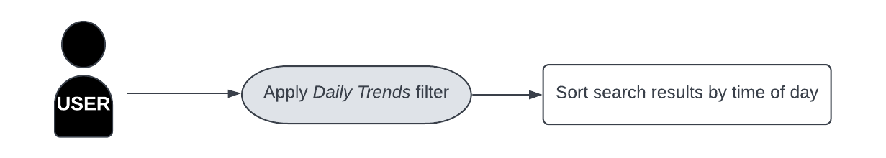

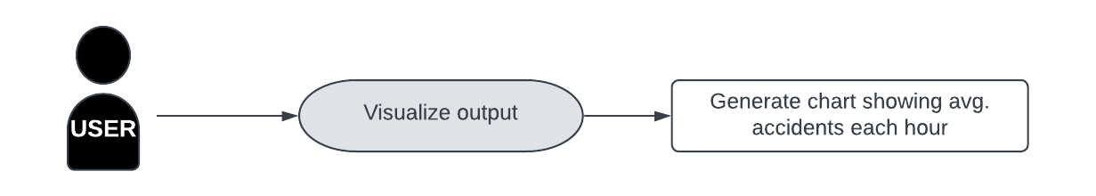

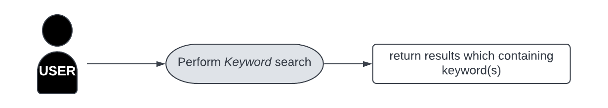

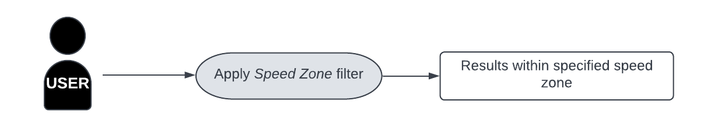

# Software Design and System Components

## Software Design

## 

## System Components

### Functions

Preliminary list of all functions in the software. For each function in the list the following information is provided:

* a brief description of what it does (1 or 2 sentences);
* a list of the input parameters, and their data types, and what they are used for;
* a list of any side effects caused by the function (ie change global or member variables, changes data passed by reference from calling function etc)
* a description of the function’s return value

### Data Structures / Data Sources

List of all data structures in the software (eg linked lists, trees, arrays etc) or eternal data sources. For each data structure in the list the following information is provided:

* Type of structure (tree, list etc),
* Description of where and how it is used
* List of data members, and what each one is for do
* List of functions that use it

### Detailed Design

Pseudocode for all non-standard / non-trivial algorithms that operate on data structures

# User Interface Design

This is your initial interface design. Describe the tools you used for this design stage and any key findings that informed your design. This introduction is descriptive and should explain what you have completed for the actual design work you will present in the sub-sections below.

## Structural Design

Structural design refers to the navigational and information structure of your product – the structure that supports the interface layout. How will you structure your product? How will you group your information? How will you navigate through your product? Why? This can take the form of a diagram showing structure and hierarchy, supported by a discussion and justification of your choices. Why have you made these design choices? Describe and outline the structure of your interface and of your information.

## Visual Design

Detail your visual design: Layout, visual elements, icons, graphics, style, colour, fonts general screen designs. This can be sketches, wireframes, mockups etc, supported by a discussion, explanation, and justification of your choices.